Adam O’Mahony - T00227115.

10.1 Sprint 1 – Programming Language & POC Base DB Engine.

Sprint Description | Sprint Start Date | Sprint End Date
Research & Proof of Concept Base Project | 27/01 | 09/02

Items Covered in Sprint:
Item ID | Issue Description | Status
FYPID-29 | Research Which Programming Language is Suitable | DONE
FYPID-30 | Create Base File Storage | DONE
FYPID-31 | Create Base Executer | DONE
FYPID-32 | Create Base Parser | DONE
FYPID-33 | Rust Upskilling | DONE
FYPID-34 | Base Create Table Functionality | DONE
FYPID-35 | Base Insert Rows Functionality | DONE

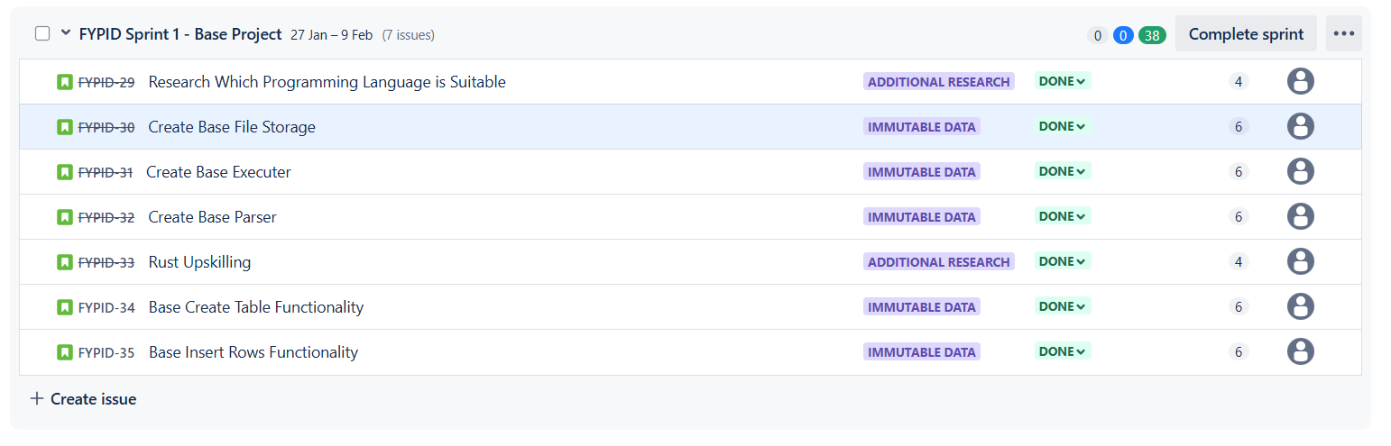
Figure 52 - Jira Sprint 1 End Snapshot

10.1.1 Choice of Programming Language & Tooling. To Java or Not to Java? FYPID-29
Research into an immutable database's ideal programming language identified C/C++, Rust, and Java as top candidates.
C/C++ excels in performance and control but requires meticulous manual memory management, posing risks to database reliability.
Rust offers comparable performance with guaranteed memory safety and robust concurrency features, crucial for a multi-threaded engine.
While Java boasts platform independence and a rich ecosystem, its garbage collection and less stringent memory model present performance and concurrency challenges.
Prioritizing performance, safety, and concurrency over rapid prototyping and a larger talent pool led to the selection of Rust for this project, offering the best balance for a robust and reliable immutable database engine.

10.1.2 Rust Programming Upskilling & Final Decision. FYPID-33
To effectively utilize Rust, a focused upskilling effort was undertaken.
This included completing several LinkedIn Learning courses:
"Rust for Java Developers," "Basics of Rust," and "Rust Web APIs,"
These courses provided a foundation in Rust's syntax, memory management, and web development capabilities.
This foundational knowledge, coupled with the language's advantages outlined in 10.1.1, solidified the decision to use Rust for the project.
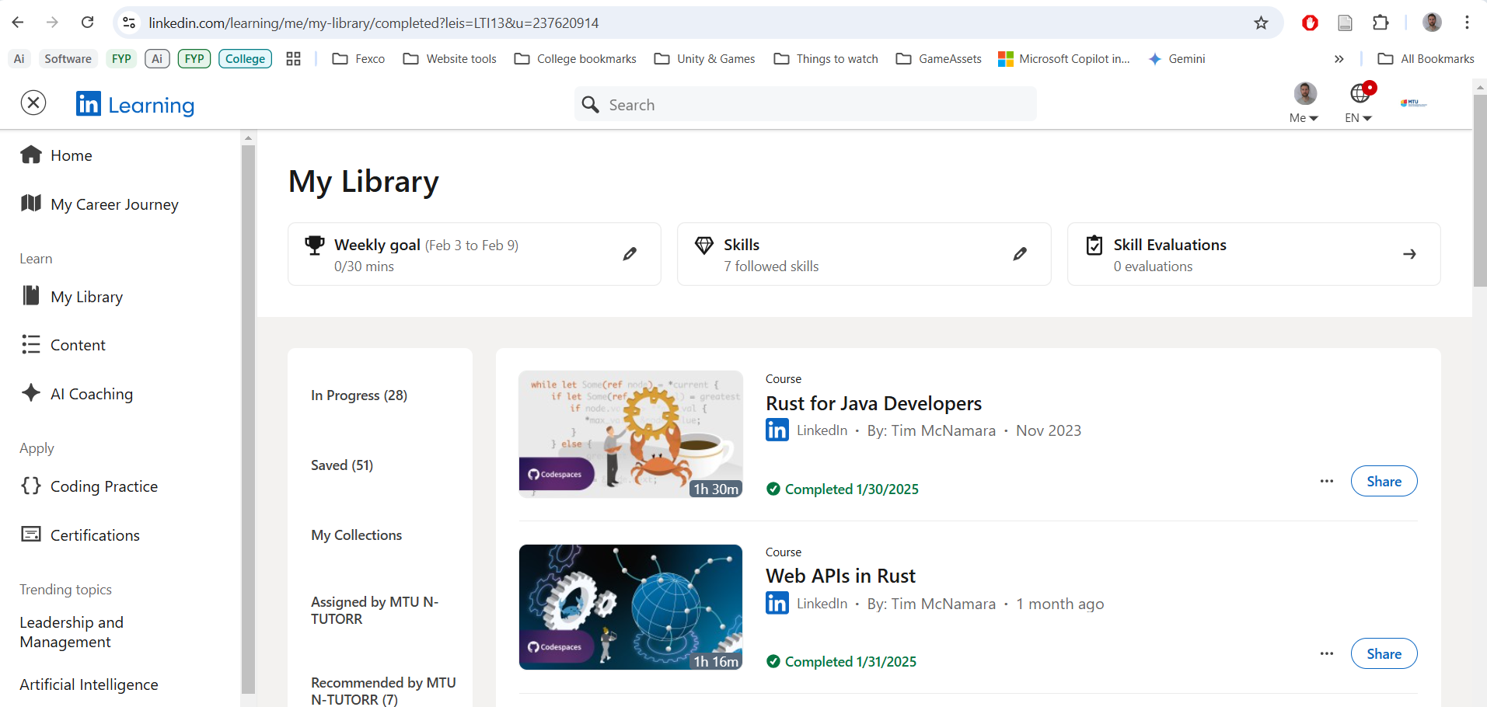
Figure 53 - LinkedIn Learning Courses on Rust

10.1.3 Creating Base Project & API capabilities. FYPID-34 & FYPID-35
The project's initial phase focused on establishing the foundational elements of the immutable database engine.
Recognizing the importance of seamless integration within a microservices environment, the core database functionalities were designed to be accessible through a robust HTTP API.
This API-first approach ensures that the database engine can be readily integrated into various microservices, regardless of their specific technology stack.
This stage involved setting up the base Rust project, implementing the core data structures for immutability, and building the initial set of API endpoints for basic data operations.

10.1.4 Creating Parser for turning SQL strings into AST nodes. FYPID-32
To enable interaction with the database using familiar SQL syntax, a dedicated SQL parser was developed.
This parser transforms SQL query strings into an Abstract Syntax Tree (AST) representation, a structured format suitable for interpretation and execution by the database engine.
This component bridges the gap between user-provided SQL queries and the underlying Rust data structures and operations.

10.1.5 Creating Executer for actioning of AST nodes. FYPID-31
Following the parsing of SQL queries into an AST, a query executor component was developed.
This executor traverses the AST, interpreting the represented query operations and executing the corresponding actions against the underlying immutable data store.
This component translates the structured query representation into concrete database operations, retrieving or manipulating data as specified by the user's SQL query.

10.1.6 Create Base File Storage. FYPID-30
A basic file storage system was implemented to provide persistent storage for the immutable data.
This system handles the writing and reading of data records to disk, ensuring data durability and persistence across application restarts.
This initial implementation focused on core functionality, providing a foundation for more advanced storage and retrieval mechanisms in later stages.
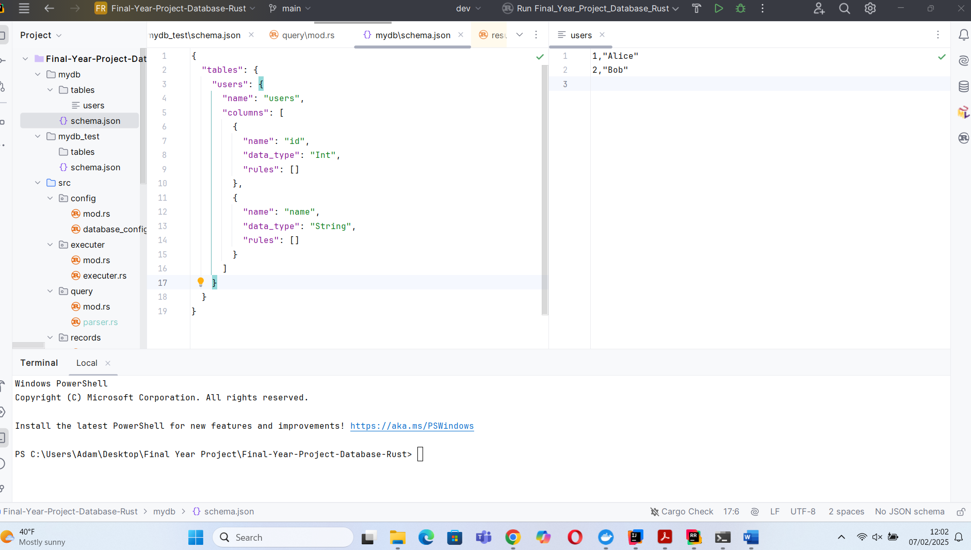
Figure 54 - Basic File storage of Schema and User data
For the in-memory cache, the Rust BTreeMap data structure was employed to store the data in an efficient and searchable tree structure.
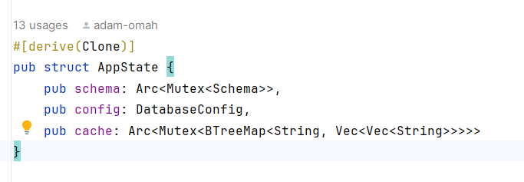
Figure 55 - Rust BTreeMap used for Cache

10.1.7 API Testing with Postman.
Basic API testing was performed to verify core functionality.
Postman was used to test table creation and data insertion endpoints, confirming successful execution and correct handling of basic database operations.
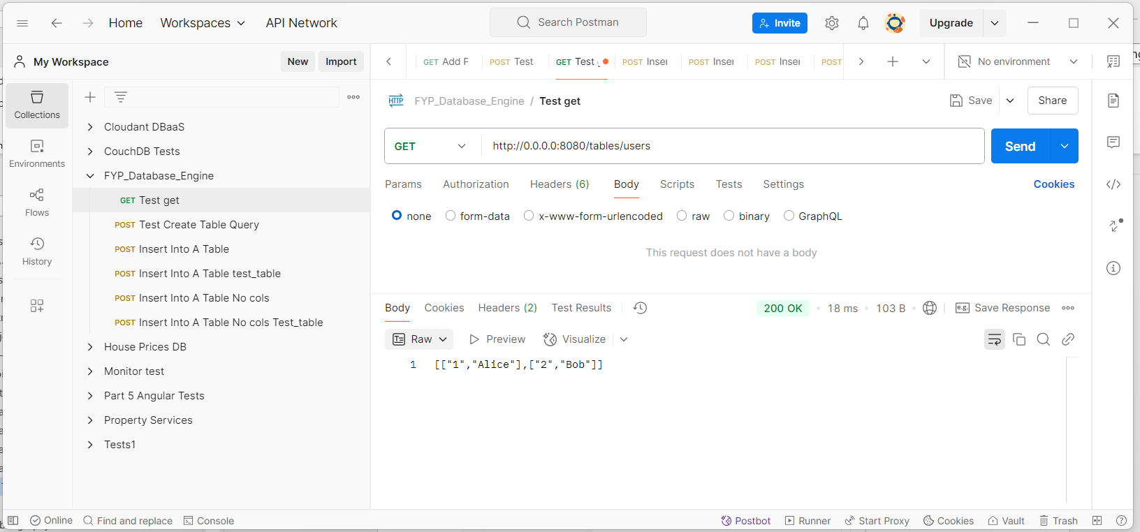
Figure 56 - Postman used for API End-point testing

